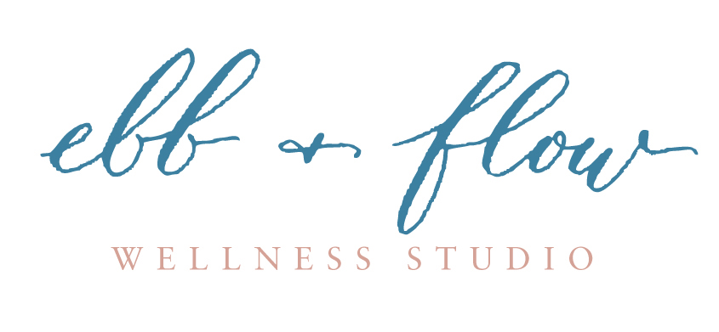

Application Form Ebb & Flow 250YTT 2019– A 250hr Certified Yoga Teacher Training
Full Name…………………………………………………………………………………..
Address………………………………………………………………………………………
………..………………………………………………………………………………………
Phone number/mobile………………………………………………………………………
Date of Birth………………………………………………………………………………
Why do you want to do this course?
…………………………………………………………………………………………………………………

What relevant qualifications do you have?
............................................................................................................................................................

What experience do you have with Yoga? How long have you been practicing yoga? (A min of 12mth practice is required.)
…………………………………………………………………………………………………………………
…………………………………………………………………………………………………………………
Is there anything we need to know in order to make this experience fabulous for you?
………………………………………………………………………………………………………………….

Preferred Payment – Please pay DD and send email of receipt
Early bird I would like to pay deposit $1000 by Nov 1st 2019 / then Balance of $3000 to get discount on total course costs ($4000) before Jan 30th 2019 to secure my place. YES/ NO
Full Payment I would like to secure my place with full payment of $4400 by Jan 30th 2019. YES/ NO
If you’d like a payment plan email us.

Signature and Date …………………………………………………………
Please Pay into account and email us this signed application to info@ebbandflowwellness.com.au
Ebb and Flow Wellness Studio BSB 013642 AC no. 224 820 032 please put surname and course for ref

